Experiment 2
TABLE CREATION AND VALUE INSERTION
QUERY
1.create table Instructor_55(instructor_id int primary key,Name varchar(30)NOT NULL,Department VARCHAR(30));
desc instructor_55;

2.create table course_55(course_id int primary key,Title varchar(30) NOT NULL,Credits int check(Credits>0),instructor_id int,FOREIGN KEY(instructor_id)references instuctor_55(instructor_id));
desc course_55;
3: create table Student_55_(roll_no int primary key,Name varchar(30) NOT NULL,DoB date,department varchar(30));
desc Student_55_;
4: create table Enrollement_55_(Roll_no int ,course_id int,grade char(2),primary key (Roll_no,course_id), FOREIGN KEY (roll_no) REFERENCES Student_55_(roll_no)ON DELETE CASCADE,
FOREIGN KEY (course_id)references course_55(course_id)ON DELETE CASCADE);
DESC Enrollement_55_;

output:
1: table Instructor_55 created.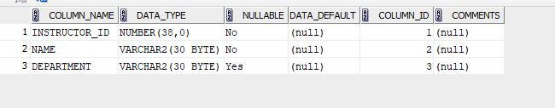
2:table course_55 created
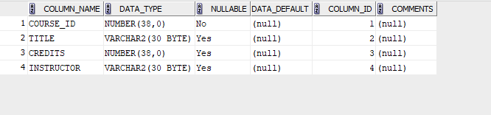

3:table Student_55_ created

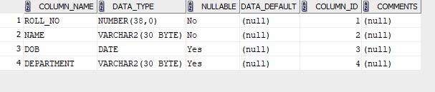
4:
